PreStack Description (Build 18, 2/16/2023)

Overview:

PreStack is a utility for assembling image files into a directory structure which is optimized for PixInsight image processing. For each set of target images (by directory), the user can select a set of flat images (by directory), a Bias master and a Darks master. The program will segregate light images by position angle (for rotation) and associate corresponding flats. Image files are moved into newly organized directories. Flats, Bias and Darks images are copied so they may be reassembled with subsequent targets.

Operation:

Image Directory: List of directories of images as found in Humason or CCDAP folders. These directories are organized by target and date. One or more can be selected for assembly.

Flats Directory: List of directories, by date, as found the Humason folder. One can be selected for assembly.

Bias Master Files: List of Bias Master FITS files as found in the PreStack folder. Master files must be compiled using PixelInsight or some other application before assembly.

Darks Master Files: List of Dark Master FITS files as found in the PreStack folder. Master files must be compiled using PixelInsight or some other application before assembly.

Target: Display of target name as derived from the selected Image Directory.

Source: Image and Flats Directories will be chosen from Humason or CCDAP defaults.

Assemble: Moves or copies all image files into the PreStack file organization in preparation for easy loading into PixInsight.

Filter Flats: Culls all Flats whose average ADU is not between 20-40K.

Close: Close application.

Requirements:

PreStack is a Windows Desktop Application, written in C#. The application runs as an uncertified, standalone application under Windows 10/11. The utility requires TheSky 64 to assist with culling flats.

Installation:

Download “PreStack64Buildxxx.zip” from the GitHub directory at <https://github.com/rrskybox/Darks-Knight/tree/master/Darks%20Knight/publish>. Extract to a local folder. Run “setup.exe” and disable Windows security blocks for uncertified applications. Upon completion, an application icon will have been added to the start menu under the category "TSX Toolkit" with the name "PreStack". This application can be pinned to the Start Menu if desired. In addition, TheSky must be run in Administer mode one time and only one time in order to register its interface libraries.

Operation:

Support:

This application was written for the public domain and as such is unsupported. The developer wishes you his best and hopes everything works out, but recommends learning Visual Basic (it's really not hard and the tools are free from Microsoft) if you find a problem or want to add features. The source is supplied as a Visual Studio 2019 project directory.

Input File Structures:

Humason File Organization

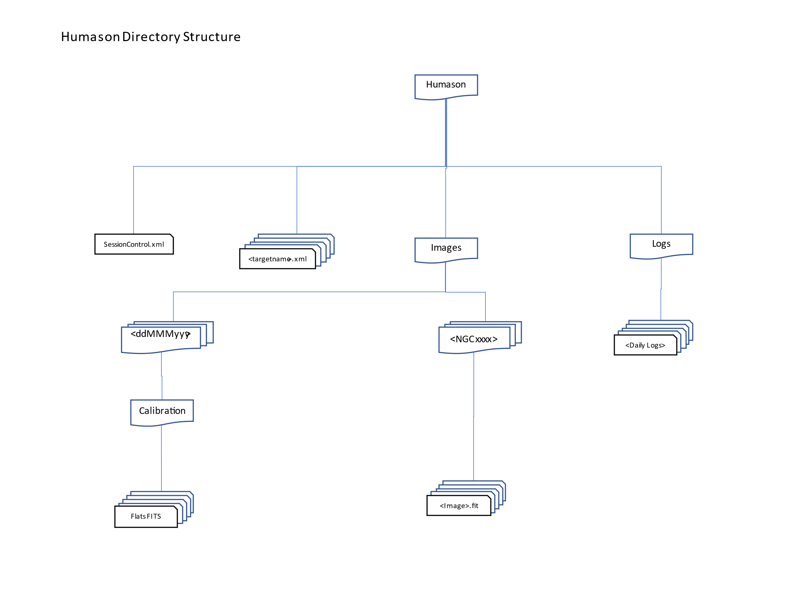

DarksKnight (Darks and Bias) File Organization

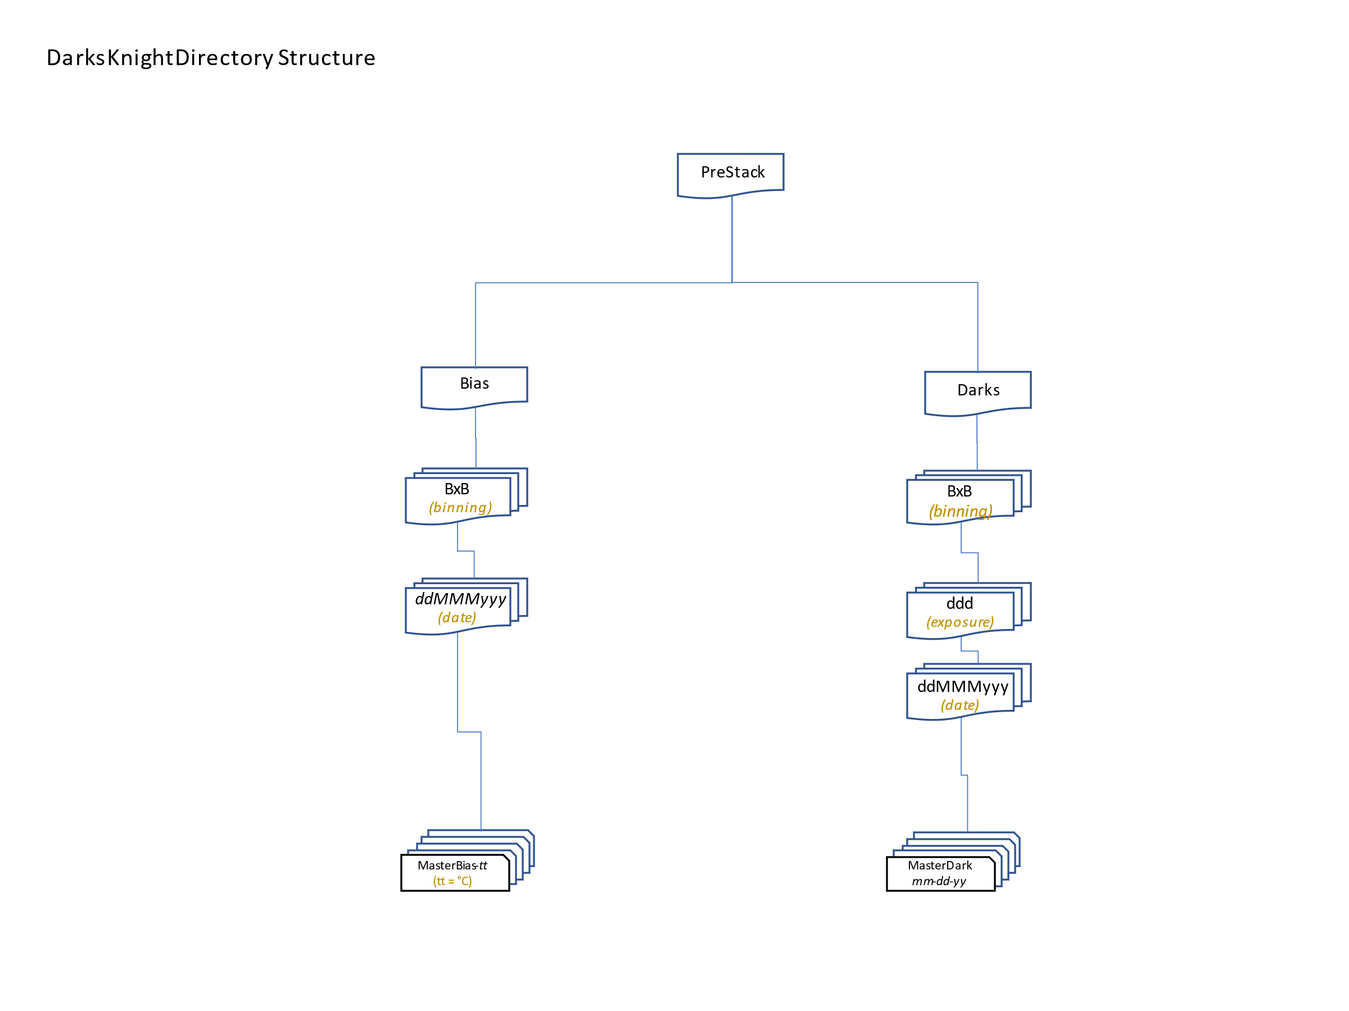

PreStack Output File Organization

